**TSRT9 Code Assembler – Instructions to Edit**

1. 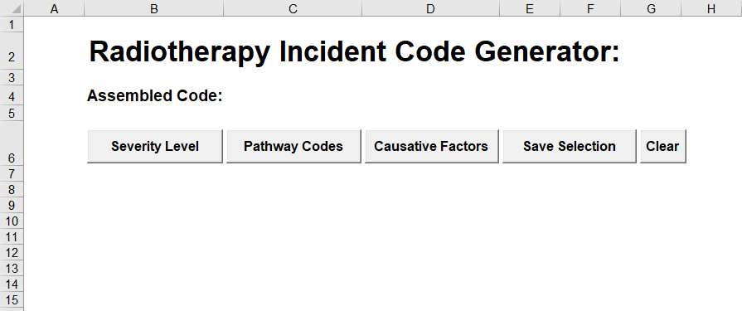Ensure the spreadsheet is blank
2. 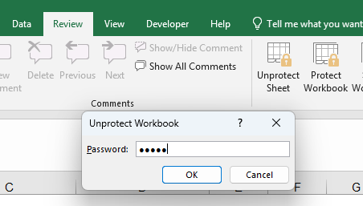Go to “Review” on the main ribbon, and select “Unprotect Workbook” (it may say “Protect Workbook” as in the example, but the pop-up will still be to unprotect the workbook). Enter the password “TSRT9”
3. Right click the sheetname “Code Assembler” and unhide the sheets that are needing to be edited

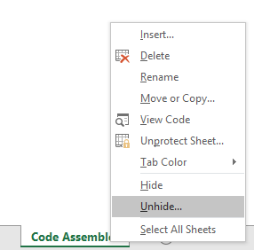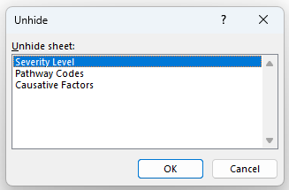

1. Ensure to stick with the structure already present in the spreadsheets. The forms are procedurally generated from these codes so it is vital to ensure the structure remains consistent
   1. The severity code is what appears in the button within the form. The next two columns are concatenated together when creating the description for the severity
   2. For both the pathway codes and causative factors, the category determines the button needing to be pressed for the form to display that particular code. These must be identical otherwise another option will be created.  
        
      The code is the part bring recorded and shown in the TSRT9 code  
        
      The description is the taxonomy description of the pathway code  
        
      Safety barrier shows whether the pathway code in particular is a safety barrier. In the generated userform this is shown in brackets after the code.
2. Save and close the form. The form can now be reopened and will be fully functional with the newly saved codes